

**Deakin University**

Smart Warehouse Inventory and Delivery Management System

Project Proposal

Student Name: Ocean Ocean

Student ID: S223503101

Date of Submission: 19 July,2025

Document Version 1.0

# High-Level Problem / Problem Description

* Modern warehouses often struggle with real-time stock monitoring, delivery scheduling, and maintaining optimal inventory levels. Manual systems or semi-automated solutions lack scalability and cannot adapt efficiently to demand spikes, such as during peak sales periods.
* This project proposes the development of a Smart Warehouse Inventory and Delivery Management System that utilizes IoT sensors, event-driven microservices, and cloud scalability. The goal is to automate stock monitoring, streamline order processing, and enable scalable delivery scheduling.
* Unlike traditional inventory systems, this solution uses simulated sensor data, Node-RED for event-based flow control, and scalable microservices deployed on AWS. The design supports autoscaling of services like order processing and delivery notifications, ensuring consistent performance during high demand.

# Solution overview

The proposed system will:

* Monitor inventory levels using simulated IoT sensors.
* Trigger automatic reordering when stock falls below threshold.
* Schedule deliveries via a scalable event-based microservice architecture.
* Store data in cloud databases (e.g., AWS DynamoDB).

The architecture includes sensors (simulated with Node.js), a data processing pipeline using Node-RED, microservices in Node.js, and deployment on AWS with automatic scaling.

High-level block diagram:

* Sensor Nodes (Simulated stock readers)
* Node.js Data Collector
* Node-RED Flow Processor
* Microservices (Inventory, Order, Delivery)
* AWS Infrastructure (EC2, Lambda, S3, DynamoDB)

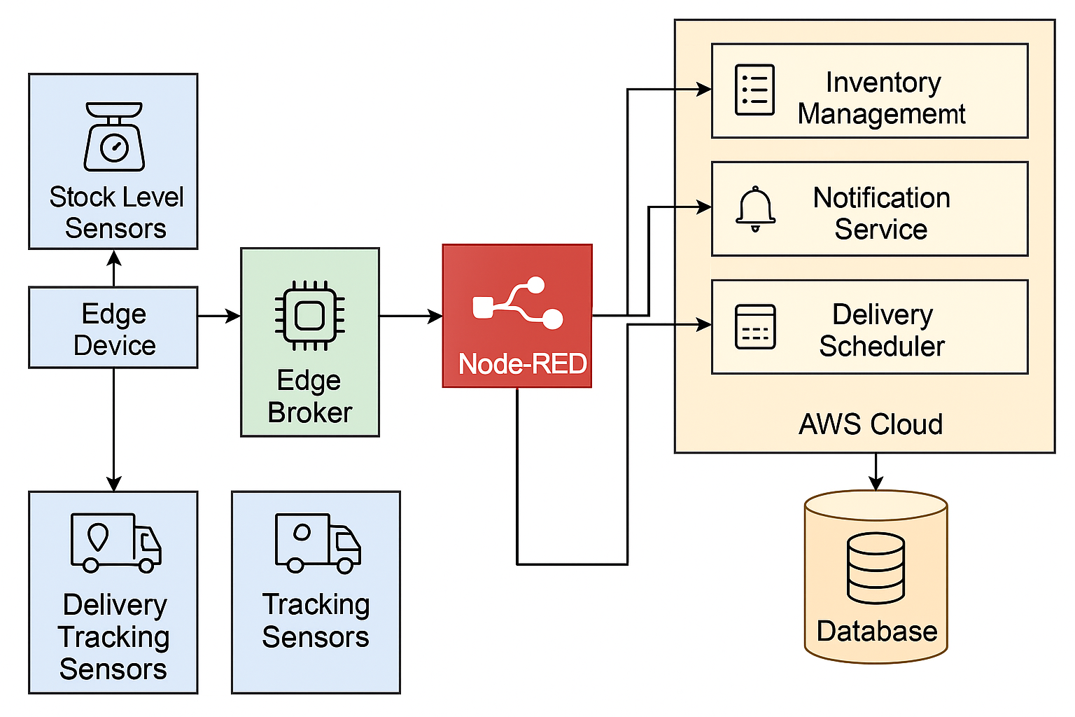

Aggregation/filtering includes averaging stock levels, filtering noise, and applying reorder thresholds. The system will be scalable through AWS EC2 Auto Scaling Groups and Lambda triggers.

Testing Plan:

* Unit testing for microservices
* Load testing on AWS with simulated traffic
* Functional testing for event handling in Node-RED
* Security testing using IAM and HTTPS endpoints

# Implementation Plan

Hardware/Simulation:

* Simulated weight or RFID sensors via Node.js scripts
* MQTT or HTTP for communication
* Node-RED for rule-based flows

Communication:

* MQTT for sensor-to-gateway messaging
* HTTP/REST for microservices

Data Design:

* Inventory Data: item_id, stock_level, last_updated
* Order Data: order_id, item_id, quantity, status
* Delivery Data: delivery_id, address, status

Storage:

* DynamoDB for scalable, document-based storage
* S3 for logs and backups

Cloud Deployment:

* EC2 for core services
* AWS Lambda for auto-triggered scaling
* API Gateway for microservice exposure
* IAM roles for secure access control

# Project Plan

|  |  |
| --- | --- |
| ***Week*** | ***Planned Activities*** |
| ***Week 1*** | *Finalize project topic (Smart Warehouse), set up GitHub repo, begin drafting project plan* |
| ***Week 2*** | *Design system architecture and high-level block diagram, research AWS & Node-RED integration* |
| ***Week 3*** | *Develop simulated sensor scripts using Node.js to represent stock levels* |
| ***Week 4*** | *Implement Node-RED flows to process sensor data and trigger events* |
| ***Week 5*** | *Create core microservices: Inventory Manager, Order Handler, Delivery Scheduler* |
| ***Week 6*** | *Deploy microservices to AWS EC2, configure AWS Lambda and Auto Scaling Groups* |
| ***Week 7*** | *Set up DynamoDB (for inventory & orders), S3 for log storage, secure access with IAM* |
| ***Week 8*** | *Conduct functional, integration, and load testing of the full system* |
| ***Week 9*** | *Finalize documentation, gather screenshots/logs, export plan to PDF, submit to OnTrack* |

Potential Risks:

* AWS billing limits or misconfiguration
* Delays in integrating services
* Inconsistent simulation data

Cloud deployment issues due to IAM roles or policy errors